**HEART DISEASE PREDICTION**

**Using : Anaconda (jupyter notebook)**

Step1 : import pandas as pd

import numpy as np

import matplotlib.pyplot as plt

import seaborn as sns

import warnings

warnings.filterwarnings('ignore')

Step2 : df=pd.read_csv('downloads/heart.csv')

Step3 : df.head()

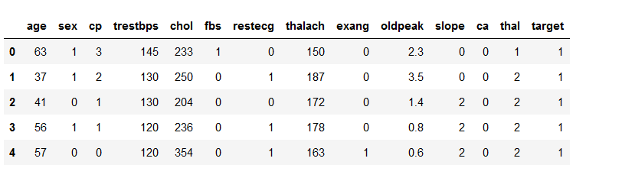

Step4 : df.isnull().sum()

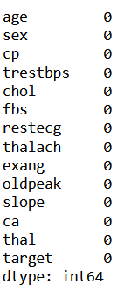

Step5:print(df.info())

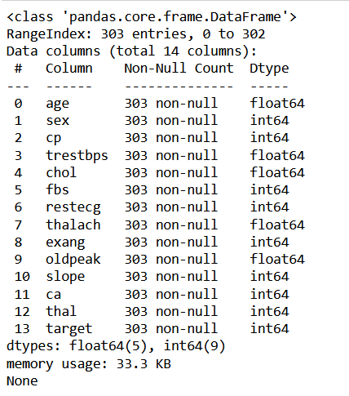

Step6 : plt.figure(figsize=(20,10))

sns.heatmap(df.corr(),annot=True, cmap='terrain')

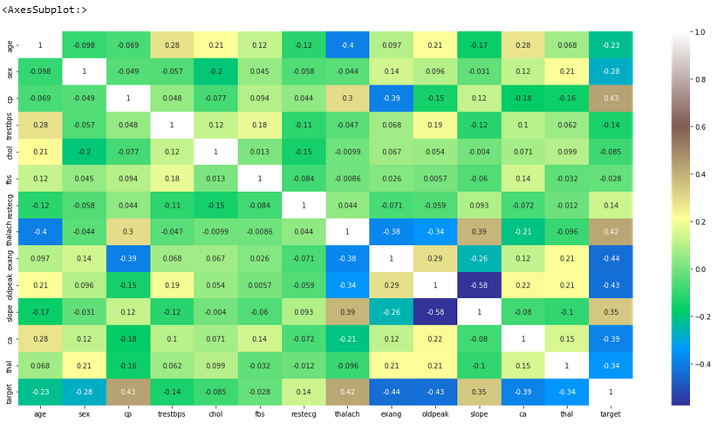

Step7 : sns.pairplot(data=df)

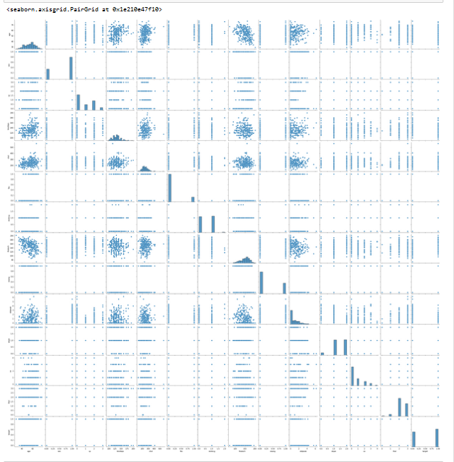

Step8 : df.hist(figsize=(12,22),layout=(5,3));

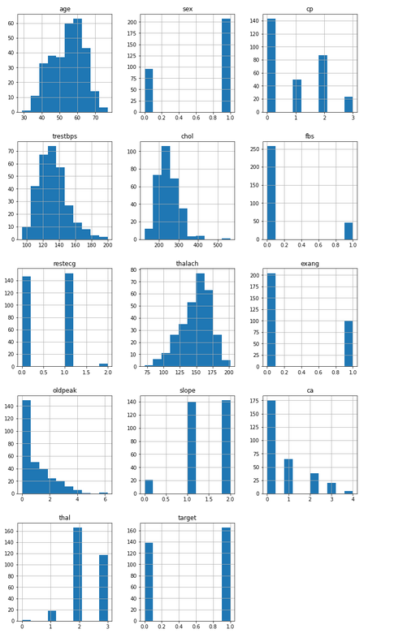

Step9 : #box and whiskers plot

df.plot(kind='box',subplots=True,layout=(5,3),figsize=(12,12))

plt.show()

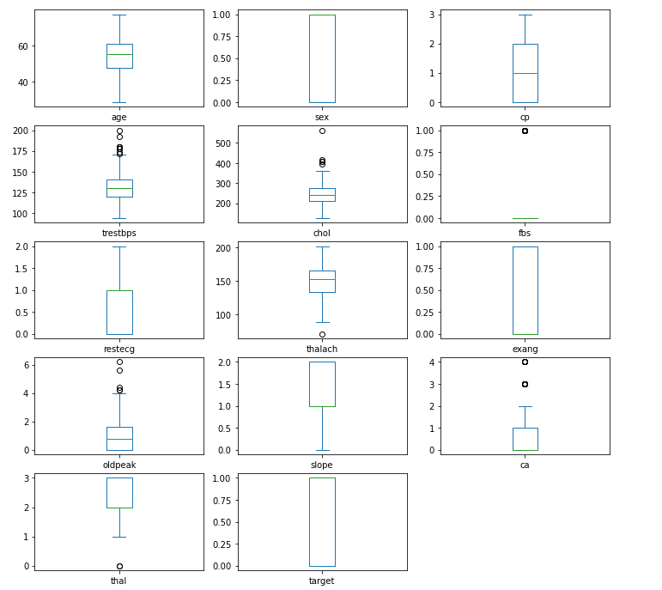

Step10 : sns.catplot(data=df,x='sex',y='age',hue='target',palette='husl')

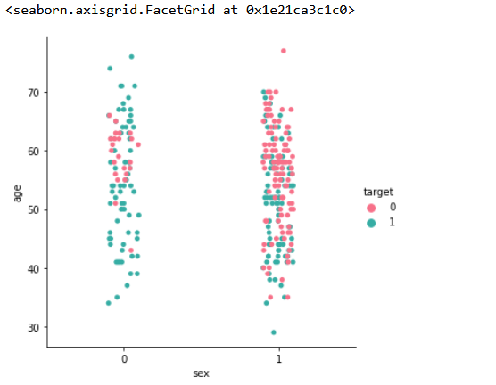

Step11: sns.barplot(data=df,x='sex',y='chol',hue='target',palette='spring')

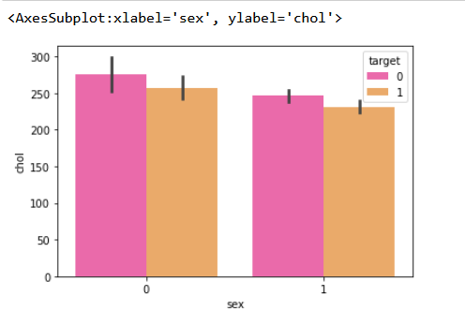

Step12 : df['sex'].value_counts()

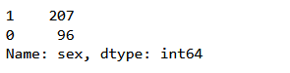

Step13 : df['cp'].value_counts()

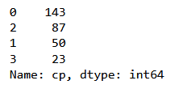

Step14 : sns.countplot(x='cp',hue='target',data=df,palette='rocket')

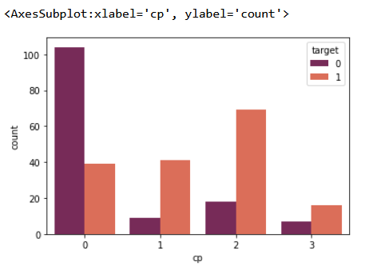

Step15 : gen=pd.crosstab(df['sex'],df['target'])

print(gen)

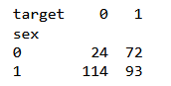

Step16 : gen.plot(kind='bar',stacked=True,color=['green','yellow'],grid=False)

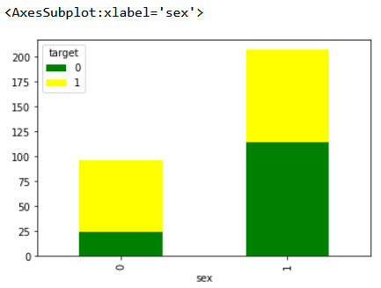

Step17 : chest_pain = pd.crosstab(df['cp'],df['target'])

chest_pain

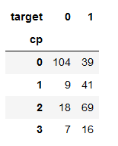

Step18 : from sklearn.model_selection import train_test_split

from sklearn.preprocessing import StandardScaler

StandardScaler =StandardScaler()

columns_to_scale=['age','trestbps','chol','thalach','oldpeak']

df[columns_to_scale]=StandardScaler.fit_transform(df[columns_to_scale])

Step19 : df.head()

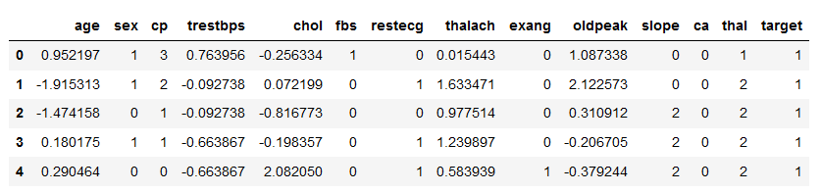

Step20 : x=df.drop(['target'],axis=1)

y=df['target']

Step21 : x_train, x_test, y_train ,y_test=train_test_split(x,y,test_size=0.3,random_state=40)

Step22 : print('x_train-',x_train.size)

print('x_test-',x_test.size)

print('y_train-',y_train.size)

print('y_test-',x_test.size)

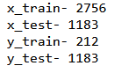

Step23 : from sklearn.neighbors import KNeighborsClassifier

knn=KNeighborsClassifier().fit(x_train,y_train)

knn.score(x_test,y_test)



Step24 : from sklearn.ensemble import RandomForestClassifier

np.random.seed(41)

rf=RandomForestClassifier().fit(x_train,y_train)

rf.score(x_test,y_test)



Step25 : from sklearn.linear_model import LogisticRegression

lr=LogisticRegression()

model1=lr.fit(x_train,y_train)

prediction1=model1.predict(x_test)

Step26 : from sklearn.metrics import confusion_matrix

cm=confusion_matrix(y_test,prediction1)

cm

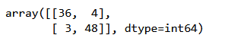

Step27 : sns.heatmap(cm,annot=True,cmap='BuPu')

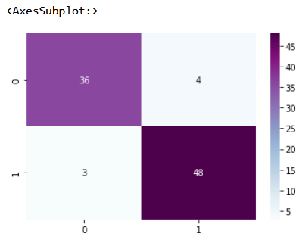

Step28 : TP=cm[0][0]

TN=cm[1][1]

FN=cm[1][0]

FP=cm[0][1]

print('Testing Accuracy: ',(TP+TN)/(TP+TN+FN+FP))



Step29 : from sklearn.metrics import accuracy_score

accuracy_score(y_test,prediction1)



Step30 : from sklearn.metrics import classification_report

print(classification_report(y_test,prediction1))

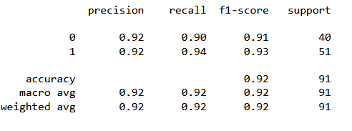

Step31 : print('lr :',accuracy_score(y_test,prediction1))



Step32 : from sklearn.metrics import confusion_matrix

prediction=knn.predict(x_test)

prediction

confusion_matrix=confusion_matrix(y_test,prediction)

confusion_matrix

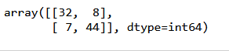

Step33 : from sklearn.metrics import confusion_matrix

prediction=rf.predict(x_test)

prediction

confusion_matrix1=confusion_matrix(y_test,prediction)

confusion_matrix1

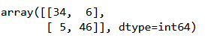

Step34 : sns.heatmap(confusion_matrix,annot=True,cmap='BuPu')

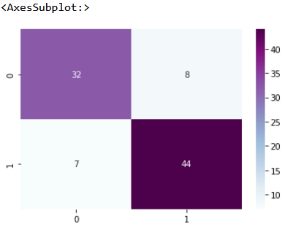

Step35 : TP=confusion_matrix[0][0]

TN=confusion_matrix[1][1]

FN=confusion_matrix[1][0]

FP=confusion_matrix[0][1]

Print('Testing Accuracy: ',(TP+TN)/(TP+TN+FN+FP))



Step36 : sns.heatmap(confusion_matrix1,annot=True,cmap='BuPu')

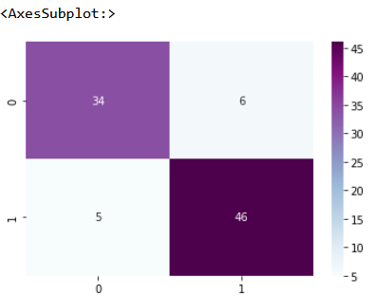

Step37 : TP=confusion_matrix1[0][0]

TN=confusion_matrix1[1][1]

FN=confusion_matrix1[1][0]

FP=confusion_matrix1[0][1]

print('Testing Accuracy: ',(TP+TN)/(TP+TN+FN+FP)

